***Character Counts***

Months in review: 2018 – 2019

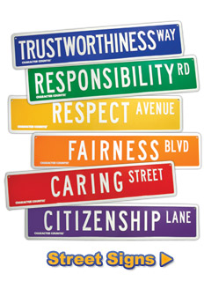

August, September: **RESPONSIBILITY**

October: **RESPECT**

November, December: **CARING**

January, February: **TRUSTWORTHINESS**

March: **FAIRNESS**

April: **CITIZENSHIP**

May: **ALL TRAITS**

Last updated 08-02-17 JM